Date: Friday, 8th May 2020
Time: 3.30pm
Location: Nhulunbuy Corporation Boardroom
Attendees: Kiyarnie Reynolds, Tegan Stiff, Sophia Rogers, Jasmin Mills, Taylah Mills, Deni Seaniger, Lucy Mander, Brianna Mery, Ali Mills (Nhulunbuy Corporation (NC) CEO and Town Board Chairperson) Vicki Blackler (Specialist, Indigenous Participation – Gove Operations Aluminium) Michael Rogers (Nhulunbuy Corporation (NC) Community Engagement Facilitator and Nhulunbuy Youth Council Liaison Officer) Joey Chalk (Specialist, Communities and Communications – Gove Operations Aluminium)
Arrived late:
Apologies: Jordon Hay
Previous Meeting: 6th March 2020
- Meeting commenced at 3.34pm
- Michael Rogers (Mike) commenced the meeting with the Acknowledgement of Country
- Mike Rogers got the adults to introduce themselves and advised everyone that Joey Chalk would be videoing the meeting for a Rio Tinto Nhulunbuy Youth Council project that the Rio Tinto Communities team was putting together
- Welcome remarks by Mike Rogers (NYC Facilitator) to the newly appointed Youth Council Members: Briana Mery, Deni Seaniger, Jasmin Mills and Lucy Mander – presented each new member with Nhulunbuy Youth Council hats/caps
- Mike Rogers got all members to do a quick introduction
- Ali Mills – NC CEO and Town Board Chairperson introduced herself and then went on to discuss the organisational structure, roles and responsibilities of the Board of Directors, Town Board and Nhulunbuy Corporation (NC). Ali also talked about what governance is 'the framework of rules, relationships, systems and processes within and by which authority is exercised and controlled in, the linkage the Youth Council has with the Town Board and the need to have a more bilateral approach in 2020

Correspondence
- Nhulunbuy Youth Council Member Sophia Rogers emailed a request regarding a possible project/initiative to initiate/facilitate and be part of
- Sophia stated that the Canteen external walls at Hindle Oval was in need of an upgrade and suggested that consideration should be made in regards to the sports that are played at Hindle Oval and the inclusion of Yolgnu Art work with a theme around sport played at Hindle Ovals and healthy lifestyle
- This idea was unanimously supported. Kiyarnie Reynolds was nominated to speak to her High School art teacher around the possibility of being involved, whether in an idea capacity or in an assisting role
- Mike Rogers was to look at local alternative artists as a backup to the school being unable to assist
Youth Grants

- In less than a fortnight, the Nhulunbuy Youth Council will receive an invitation from the Office of Youth Affairs, Dept of Chief Minister for an upcoming Youth grant
- 25k is to be allocated before 30th June and 50k is to be allocated for the 20/21 financial year
- This grant is to provide school holiday activities and for where possible, school hours and during school term activities

General Business

- Vicki Blackler asked the Youth Council members if they had any ideas designed to back new and existing initiatives that are responding to the urgent needs of young people at this time with COVID-19. Vicki asked the members to think about there experiences and how COVID-19 affected them

- Mike Rogers asked the Youth Council to really start considering alternatives for the concrete pads that were once used for the Green Waste Recycling Bins. The Town Board has requested that the Nhulunbuy Youth Council look at ways to make these area’s workable

- Mike Rogers requested shirt sizes from each member for the upcoming order of Nhulunbuy Youth Council Shirts

Photo

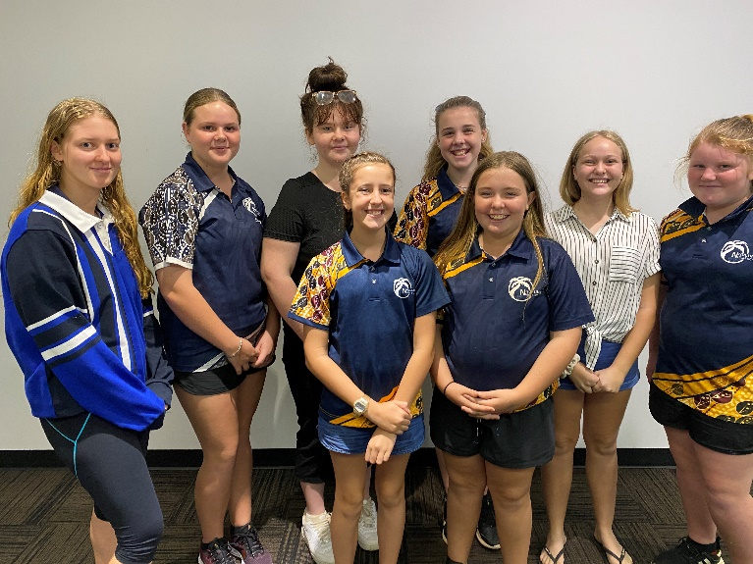

Nhulunbuy Youth Council Members 2020

- (Left to Right) Tegan Stiff, Kiyarnie Reynolds, Taylah Mills Sophia Rogers, Brianna Mery, Deni Seaniger, (Front) Lucy Mander and Jasmin Mills (Absent) Jordon Hay

Next meeting
- The next meeting is planned for the 5th June at 3.30pm.

Meeting Close
- Nhulunbuy Youth Council meeting concluded at 5.24pm

Michael (Mikey) Rogers
Nhulunbuy Youth Council Facilitator
0455 552 338​

